
Bowbrook Primary School
Squinter Pip Way, Shrewsbury, SY3 8PX
01743 816891
www.bowbrookprimary.co.uk

Kitchen Lunchtime Assistant
7.5 hours per week, Monday to Friday
Working times 11.30-1:00pm, £11.59 per hour
Term Time 43.89 wks, Permanent

To start as soon as possible

Can you serve our school lunches to our Nursery, Reception and Year 1 Children and clean down after service?

If so, we want to hear from you.

Bowbrook is a vibrant new Primary School in Shrewsbury so you will be joining a brand new school team.

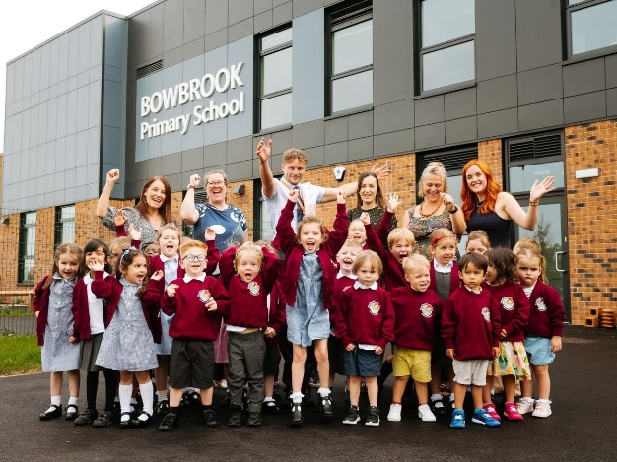

We are seeking to appoint a positive, friendly person with lots of energy and initiative who can make our dining hall a welcoming place for children at lunchtimes.

If you want to be our Kitchen Lunchtime Assistant and wish to find out more, please contact Office Co-ordinator Sarah on 01743 816891 who will be happy to chat with you and show you around our school.

Further information and an Applicant Information Pack can be found on our website www.bowbrookprimary.co.uk

The 3-18 Education Trust is committed to safeguarding and promoting the welfare of children and young people. Successful candidates will be subject to an Enhanced DBS check, and satisfactory references. Successful candidates will be subject to an enhanced DBS check, satisfactory references and an online search.

